 | 12.1.15 Editors - Geometry Nodes Editor - Header - Add Menu - Geometry
Table of content
Detailed table of content 1
Add menu - Geometry 1
Geometry to Instance 1
Join Geometry 2

Detailed table of content
Detailed table of content
Detailed table of content 1
Add menu - Geometry 1
Geometry to Instance 1
Inputs 1
Geometry 1
Outputs 2
Instances 2
Join Geometry 2
Inputs 2
Geometry 2
Output 2
Geometry 2

Add menu - Geometry
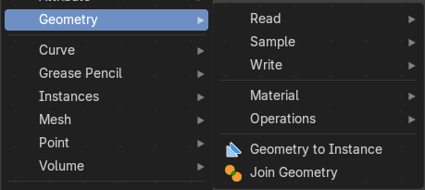
Here you find nodes to modify the geometry.

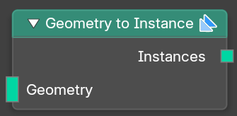
Geometry to Instance
Turns every connected input geometry into an instance. These instances can then for example be used in the Instance on Points node.

Inputs

Geometry
The input geometry.

Outputs

Instances
The output instances.

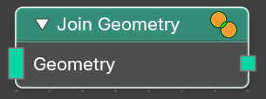
Join Geometry
The Join Geometry enables you to merge separately generated pieces of geometry into a single one. In case that the inputted pieces contain different types of geometry, the output will contain multiple types of geometry.

Inputs

Geometry
Standard geometry input.

Output

Geometry
Standard geometry output.

